**Listbox Proj**

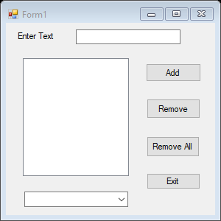

Public Class Form1

Private Sub Button1_Click(ByVal sender As System.Object, ByVal e As System.EventArgs) Handles Button1.Click

ListBox1.Items.Add(TextBox1.Text)

ComboBox1.Items.Add(TextBox1.Text)

'TextBox1.Text =""

'TextBox1.Text = vbEmpty ' add 0

TextBox1.Clear()

TextBox1.Focus()

End Sub

Private Sub Button2_Click(ByVal sender As System.Object, ByVal e As System.EventArgs) Handles Button2.Click

ListBox1.Items.RemoveAt(ListBox1.SelectedIndex)

End Sub

Private Sub Button3_Click(ByVal sender As System.Object, ByVal e As System.EventArgs) Handles Button3.Click

ListBox1.Items.Clear()

End Sub

Private Sub Button4_Click(ByVal sender As System.Object, ByVal e As System.EventArgs) Handles Button4.Click

End

End Sub

Private Sub TextBox1_KeyDown(ByVal sender As Object, ByVal e As System.Windows.Forms.KeyEventArgs) Handles TextBox1.KeyDown

If e.KeyCode = 13 Then

ListBox1.Items.Add(TextBox1.Text)

TextBox1.Focus()

TextBox1.SelectionStart = 0

TextBox1.SelectionLength = Len(TextBox1.Text)

End If

End Sub

Private Sub TextBox1_TextChanged(ByVal sender As System.Object, ByVal e As System.EventArgs) Handles TextBox1.TextChanged

End Sub

End Class

**Combobox Proj**

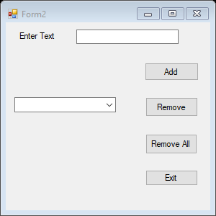

Public Class Form2

Private Sub Button1_Click(ByVal sender As System.Object, ByVal e As System.EventArgs) Handles Button1.Click

ComboBox1.Items.Add(TextBox1.Text)

'TextBox1.Text =""

'TextBox1.Text = vbEmpty ' add 0

TextBox1.Clear()

TextBox1.Focus()

End Sub

Private Sub Button2_Click(ByVal sender As System.Object, ByVal e As System.EventArgs) Handles Button2.Click

ComboBox1.Items.RemoveAt(ComboBox1.SelectedIndex)

End Sub

Private Sub Button3_Click(ByVal sender As System.Object, ByVal e As System.EventArgs) Handles Button3.Click

ComboBox1.Items.Clear()

End Sub

Private Sub Button4_Click(ByVal sender As System.Object, ByVal e As System.EventArgs) Handles Button4.Click

End

End Sub

Private Sub TextBox1_KeyDown(ByVal sender As Object, ByVal e As System.Windows.Forms.KeyEventArgs) Handles TextBox1.KeyDown

If e.KeyCode = 13 Then

ComboBox1.Items.Add(TextBox1.Text)

TextBox1.Focus()

TextBox1.SelectionStart = 0

TextBox1.SelectionLength = Len(TextBox1.Text)

End If

End Sub

End Class

**Combobox Proj**

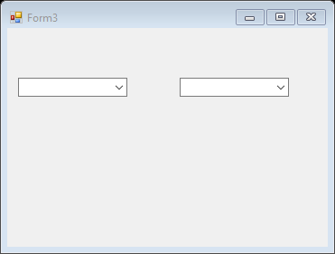

Public Class Form3

Private Sub Form3_Load(ByVal sender As System.Object, ByVal e As System.EventArgs) Handles MyBase.Load

ComboBox1.Items.Add("Day")

ComboBox1.Items.Add("Month")

ComboBox1.Items.Add("Year")

End Sub

Private Sub ComboBox1_SelectedIndexChanged(ByVal sender As System.Object, ByVal e As System.EventArgs) Handles ComboBox1.SelectedIndexChanged

If ComboBox1.SelectedIndex = 0 Then

ComboBox2.Items.Clear()

ComboBox2.Items.Add("Sun")

ComboBox2.Items.Add("Mon")

ComboBox2.Items.Add("Tue")

ComboBox2.Items.Add("Wed")

ComboBox2.Items.Add("Thu")

ComboBox2.Items.Add("Fri")

ComboBox2.Items.Add("Sat")

ElseIf ComboBox1.SelectedIndex = 1 Then

ComboBox2.Items.Clear()

ComboBox2.Items.Add("Jan")

ComboBox2.Items.Add("Feb")

ComboBox2.Items.Add("Mar")

ComboBox2.Items.Add("Apr")

ElseIf ComboBox1.SelectedIndex = 2 Then

ComboBox2.Items.Clear()

ComboBox2.Items.Add("2021")

ComboBox2.Items.Add("2022")

ComboBox2.Items.Add("2023")

End If

End Sub

End Class